Little Ossipee Lake Association 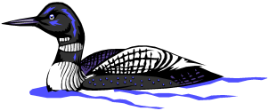

E³ Preserve and Protect Little Ossipee Lake through Education, Eradication, and Erosion Control

Thank you for your interest in the preservation of beautiful Little Ossipee Lake! Please complete and send this form along with your donation to the address shown. Spread the word to friends and family to join you in protecting Little Ossipee!

Visit us at: www.LittleOssipeeLake.org

What does Little Ossipee Lake mean to you? Please join LOLA in the effort to Protect and Preserve Little Ossipee Lake through Education, Eradication and Erosion Control

E³ Membership Dues 2017
Mall to: Little Ossipee Lake Association, PO Box 204, E. Waterboro, ME 04030
or via the LOLA Website at www.LittleOssipeeLake.org

Name:_______________________________________________________________________________

Mailing Address:_______________________________________________________________________

____________________________________________________________________________________

Lake Address: ________________________________________________________________________

Phone # 1___________________________________ Phone #2________________________________

Email Address:_______________________________________________________________________

Membership Dues: $20.00 Scholarship Donation: $___________

ICE Out April 15th LOLA Annual Meeting August 19th

